EXPERIMENT 8: Linux File System Analysis

AIM

To analyze the Linux file system and understand how files, directories, and permissions are structured and used for system management and security.

PROCEDURE

- Study the structure of the Linux file system.
- Understand important directories such as /etc, /var, /home, and /root.
- Analyze file permissions, ownership, and access controls.
- Use Linux commands to navigate and inspect files and directories.
- Identify suspicious files and potential security risks in the system.

QUESTIONS

TASK 1 - Investigation Setup 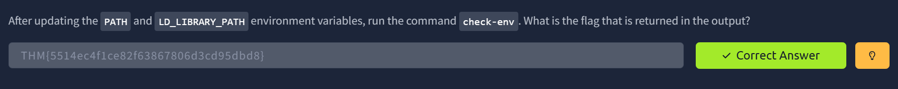
TASK 2 - Files, Permissions, and Timestamps 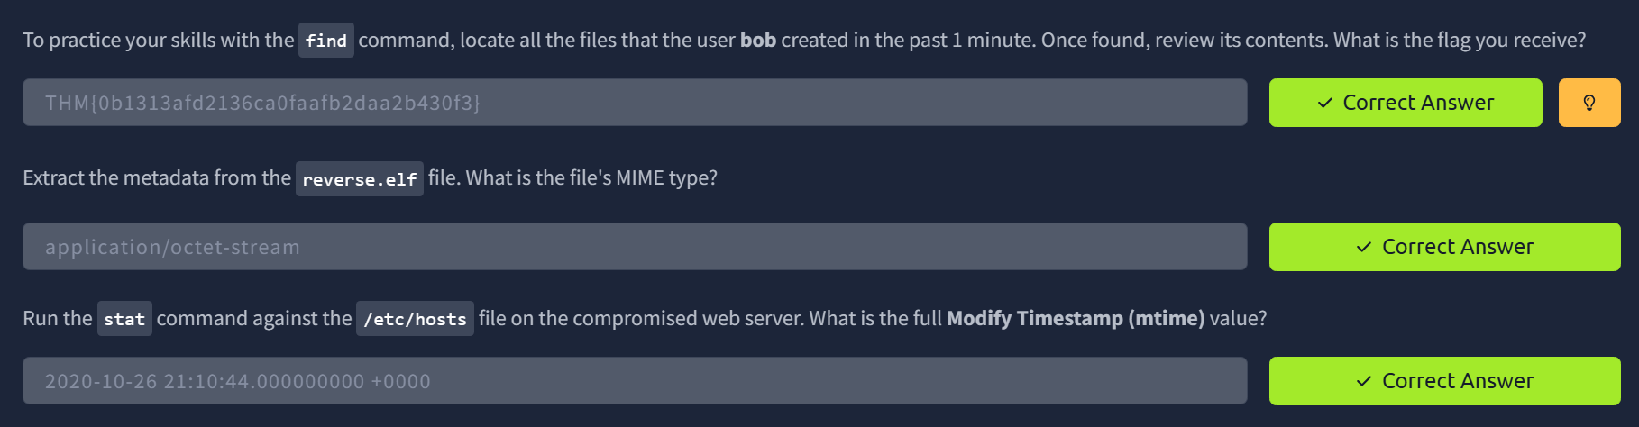
TASK 3 - Users and Groups 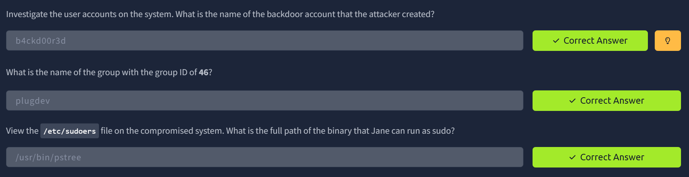
TASK 4 - User Directories and Files 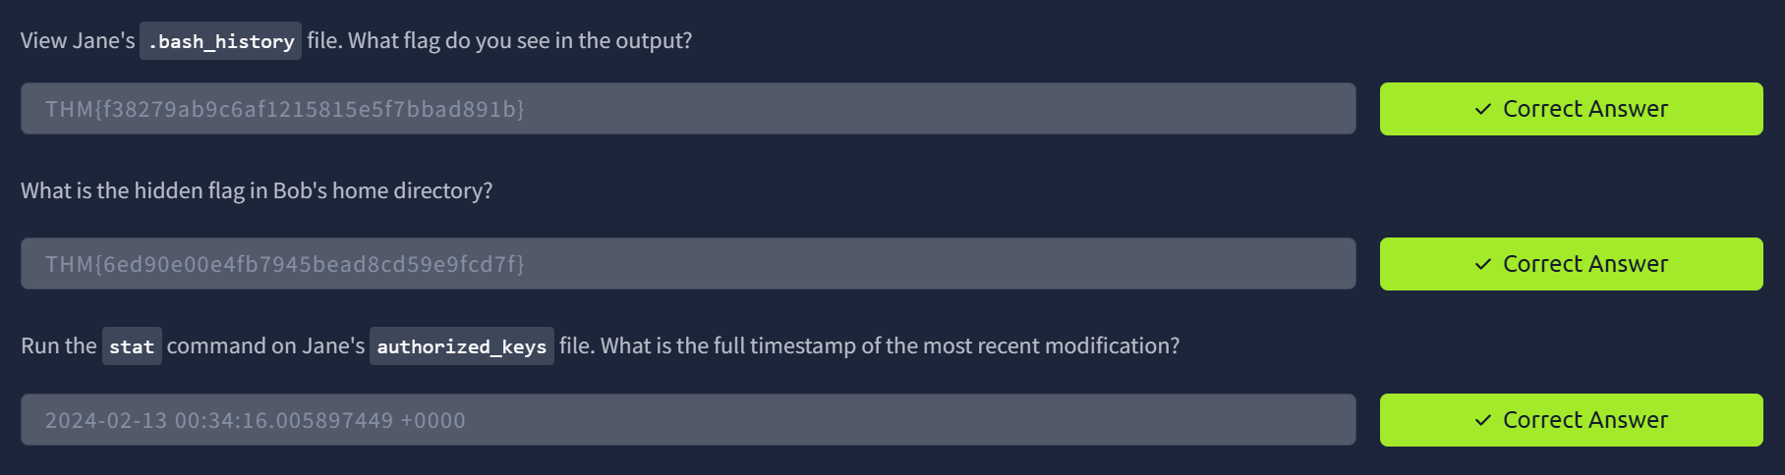
TASK 5 - Binaries and Executables 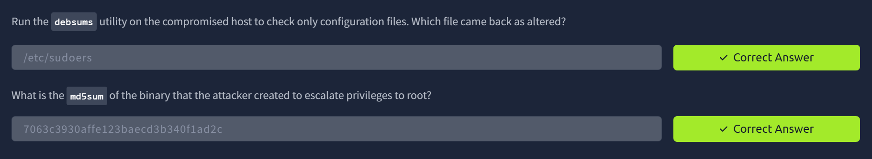
TASK 6 - Rootkits 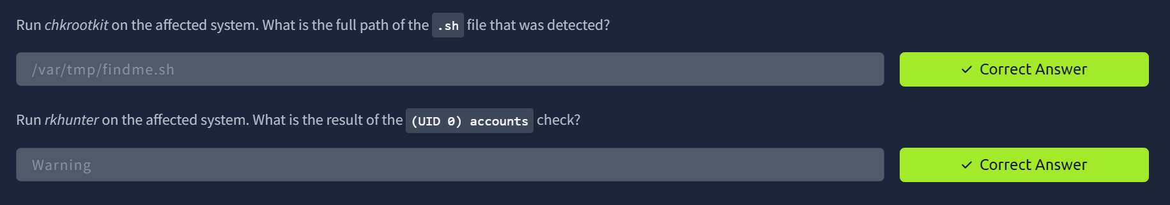

RESULT

Successfully analyzed the Linux file system and understood how file structure, permissions, and commands are used to manage and secure a Linux system.

